STAT 450

January 11, 2018

**Biosolids Activity 2**

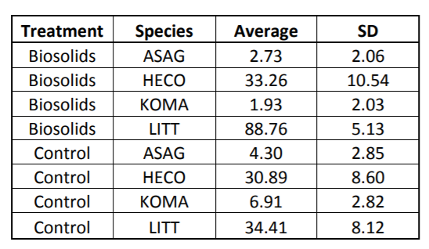

1. Based on Table 2
   1. H0: The population mean of plant cover is the same with and without treatment for species LITT (µLITT,C = µLITT,T)

Ha: The population mean of plant cover is different between with and without treatment for species LITT

* 1. Null: µASAG,C = µHECO,C = µKOMA,C = µLITT,C
  2. T = (88.76 - 34.41) / sqrt(5.13^2/4 + 8.12^2/4) = **11.32**

P-value = 2*P(tdf = 3 > 11.32) = **0.00148**

Assumptions:

* + 1. Independence of cases – this is an assumption of the model that simplifies the statistical analysis
    2. Normality – the distributions of the residuals are normal
    3. Equality (or "homogeneity") of variances, called homoscedasticity
       1. If equal variance assumption → use pooled SD
       2. Else do not use pooled SD, results will be different than F test
  1. ANOVA:
     1. SST = $nrep × \sum_{i = 1}^{t}{}ybari{}^{2}-ny..^{2}$ = 4 * (88.76^2 + 34.41^2) - 8*((88.76+34.41)/2)^2 = 5907.845
     2. MST = SST / 1 = = **5907.845**
     3. SSR= 3* (5.13^2 + 8.12^2) = 276.7539

MSR = 276.7539 / 6 = **46.12565**

* + 1. F = MST/MSR = 5907.845 / 46.12565 = **128.08155**

P-value = P(F1,6 > 128.08 ) = 2.8485*e-05

Assumptions:

1. Within groups, IID and Normal
2. Between groups, don’t know if samples are from same distribution but assume all groups have same variance
   1. Reflected in the denominator of F-statistic (MSE)

2) Use ANOVA to test 1b hypothesis at 5% significance level

Ho: µASAG,C = µHECO,C = µKOMA,C = µLITT,C

SST:

Df = 3

SSE:

Df = 4

A: Needs a benchmark - can be more informative if we look at all data

* Benchmark is pooled SD - difference in means is relevant compared to pooled SD

Treatment Avg: (2.73+33.26+1.93+88.76)/4=31.67

Control Avg: (4.3+30.89+6.91+34.41)/4=19.1275

Total Avg: 25.39875

Suppose we want to compare B vs C for just species LITT. Should we just do a t-test or take all data into account?

t^2 = F

Fact of the day: Anonymous Aurochs, a large wild Asian ox that was the ancestor of domestic cattle capable of reciting 𝝅

Harry:

Test the location of the center, not the distribution

Distribution that does not have a Expected value: cosia

*Non-parametric statistics test: comparing the whole distribution